# A2Z to Personify Order integration – Personify Data Services

# DATBASE TABLES

USR_A2Z_BOOTH_HISTORY

|  |  |
| --- | --- |
| BHID | PK,NUMERIC_ID(numeric(12,0)), not null |
| COMPANY_NUMBER | VARCHAR(50), null |
| EVENT_NAME | VARCHAR(50) , null |
| APPLICATION_DATE | DATETIME, null |
| BOOTH_AMOUNT | AMOUNT(numeric(15,2)) , null |
| BOOTH_AMOUNT_PAID | AMOUNT(numeric(15,2)) , null |
| BOOTH_AREA | decima(9,2) , null |
| BOOTH_LABEL | varchar(50) , null |
| BOOTH_HEIGHT | decima(9,2) , null |
| BOOTH_WIDTH | decima(9,2) , null |
| DATE_ASSIGNED | Datetime, null |
| ITEM | varchar(50) , null |
| PAVILION | varchar(50) , null |
| SOLD_BY | varchar(50) , null |

USR_A2Z_ORDER_HISTORY

|  |  |
| --- | --- |
| OHID | PK,NUMERIC_ID(numeric(12,0)), not null |
| COMPANY_NUMBER | varchar(50) , null |
| EVENT_NAME | varchar(50) , null |
| INVOICE_ORDER_AMOUNT | AMOUNT(numeric(15,2)) , null |
| ITEM | varchar(50) , null |
| ITEM_TYPE | varchar(50) , null |
| ORDER_DATE | Datetime, null |
| ORDER_ID | int,null |
| PAID_ORDER_AMOUNT | AMOUNT(numeric(15,2)) , null |
| PRICE | AMOUNT(numeric(15,2)) , null |
| QUANTITY | int,null |
| SALES_PERSON | varchar(50) , null |

USR_A2Z_OVERALL_HISTORY

|  |  |
| --- | --- |
| OVHID | PK,NUMERIC_ID(numeric(12,0)), not null |
| COMPANY_NUMBER | varchar(50) , null |
| EVENT_NAME | varchar(50) , null |
| ADVERTISING_AMOUNT | AMOUNT(numeric(15,2)) , null |
| BOOTH_PERSONNEL_AMOUNT | AMOUNT(numeric(15,2)) , null |
| BOOTH_SPACE_AMOUNT | AMOUNT(numeric(15,2)) , null |
| CANCELLATION_AMOUNT | AMOUNT(numeric(15,2)) , null |
| MIS_AMOUNT | AMOUNT(numeric(15,2)) , null |
| PREMIUM_SPACE_AMOUNT | AMOUNT(numeric(15,2)) , null |
| SPONSORSHIP_AMOUNT | AMOUNT(numeric(15,2)) , null |
| WEB_REVENUE_AMOUNT | AMOUNT(numeric(15,2)) , null |
| TOTAL_AMOUNT | AMOUNT(numeric(15,2)) , null |
| TOTAL_AMOUNT_INVOICED | AMOUNT(numeric(15,2)) , null |
| TOTAL_AMOUNT_PAID | AMOUNT(numeric(15,2)) , null |
| TOTAL_BOOTH_AREA | decima(9,2) , null |

# oData Services

Create read/write Entities for the following objects in Personify Web Services Designer.

* USR_A2Z_BOOTH_HISTORY
* USR_A2Z_ORDER_HISTORY
* USR_A2Z_OVERALL_HISTORY

Create the following service operations

UserDefined_A2ZGetCompanyIdsToSync

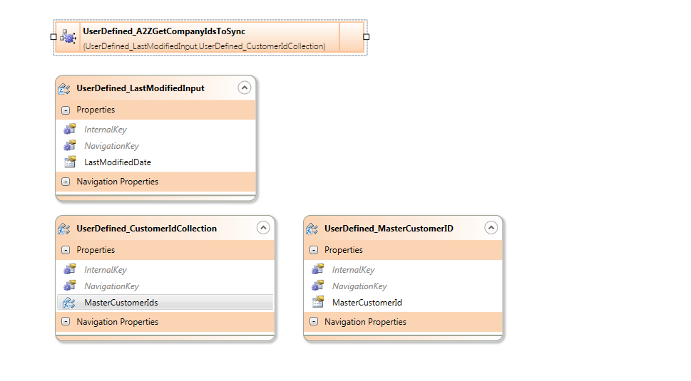

IFT is selecting Master_Customer_Id from the following tables when the ADDDATE or MODDATE is GTE to the *LastModifiedDate*

* CUSTOMER; CUS_ADDRESS_DETAIL; CUS_COMMUNICATION; CUS_ADDRESS

UserDefined_A2ZDeleteBoothHistory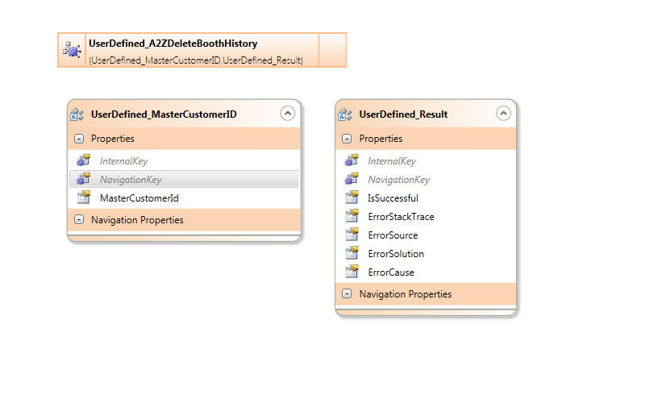

UserDefined_A2ZDeleteOrderHistory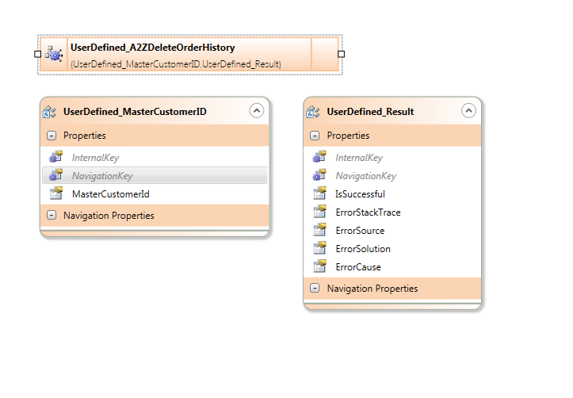

UserDefined_A2ZDeleteOverallHistory